TC2 – No/less valves simultaneous

Introduction
In 2025 we introduced the TC2 as a successor of the BCS2. The TC2 is used to control cow cooling, this is done based on a combination of ventilating and spraying water over the cows. The BCS2 had a wide range of controls from climate and curtains to lighting and manure scrapers. For the development of TC2 we focused on the cow cooling, and took over the controls for mix ventilation and spraying. We tried to improve the control where needed, we added new features and left out functions that are no longer needed.
One of the functions we didn’t takeover was the function to prevent valves opening simultaneous to prevent losing water pressure. Although we asked it several times DeLaval decided that it was not needed anymore.
Now, after the first projects, DeLaval found out this was not the right decision and they asked Hotraco to add this feature to their new TC2 controller.

Controls

BSC2 solution
As mentioned the BSC2 already had this function. The way it was implemented was very complicated and rigid. When the function shift pulses was activated the BSC2 made sure there could be only 1 spraying valve active at a time. Every valve got certain timeslots, regardless whether there was a cooling request for that valve the timeslot was blocked.

New solution
For the TC2 we want a control that is less complicated and more flexible than we had on BSC2. Instead of fixed timeslots for every valve we want to work with a que. We add valves at the moment they have cool request and want to start their pulse. We remove the valves when the pulse is ready or one of the conditions for cooling falls away.
By executing the spraying in the order the valves are added to queue, we make sure all valves get an even chance to get their turn.
The valve that is at the top of the queue gets permission to spray other valves will have to wait until the first valve is ready and gets removed from the queue. In this way we prevent that a valve blocks spraying while it has no cooling request.
Working with a queue makes it easy to add extra flexibility. Instead of allowing only the top valve to start spraying, we can make it adjustable how many valves may spray at once.

Delay fans off valve on
To prevent the fans blowing the water to the wrong spot, the current TC2 software has the possibility to connect the circulation to the spraying. When the circulation is connected to spraying, the fans will go to a lower level before the spraying is started. The air speed doesn’t go down immediately, therefore the delay fans off valve on can be set.
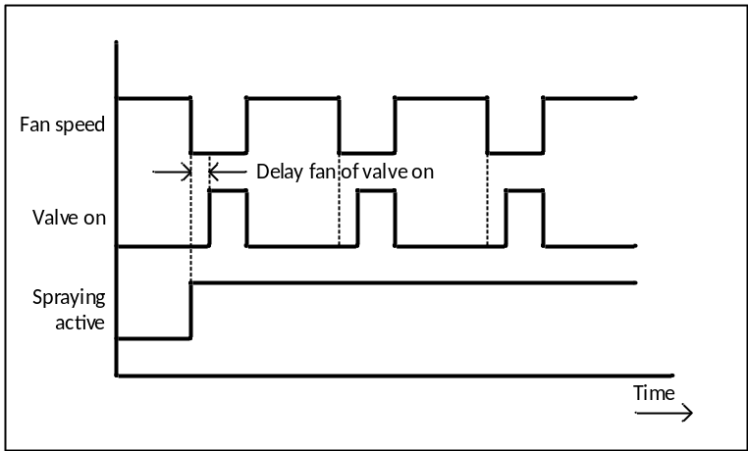
Figure 1: Timing diagram showing the effect of delay fans of valve on.
By adding the new function it will occur that the spaying will be postponed until other valves are ready. This affect the working of the ‘Delay fans off valve on’. There are several ways to solve this:
- Decrease the fan speed for the next valve before the previous is finish based on the set delay, so the nest valve opens at the moment the previous fan stops.
- Decrease the fan speed and wait for permission to spray.
- Wait for permission to spray before decreasing the fan speed.
The first method makes the control way more complex, the second method will cause more downtime for the fans, the third will cause some extra delay for the spraying. Since the delay between reducing fan speed and opening the valve is normally pretty short (probably 5 to 10 seconds). We assume it is best to go for the third option, and wait for permission to spray before decreasing the fan speed.
Pleas note: Besides ‘Delay fans off valve on’ there is also a ‘Delay valve off fans on’. A valve should only block others during the pulse time and during ‘Delay fans off valve on’. During ‘Delay valve off fans on’ the value should no longer be blocking others and

Cyclical control
When the spraying is active the valves are normally switched on and off based on a pulse and cycle time. Limiting the number valves that may be opened simultaneously affects this cyclical control. If we stick to the original cycle time and shift the pulse within the cycle there can occur undesired situations. In case a pulse is postponed so long that it cannot be finished in the original cycle it could merge with the pulse of the next cycle. In case a pulse is postponed and the pulse of the next cycle is not it could occur that the valves are switched on two times short after each other, while the fur of the animals is still wet.
The easiest way to solve these types of problems is to start the cycle at the moment the zone gets permission to open the valves. If a cycle is finished and the zone doesn’t get permission to open the valve for the next pulse the timer will stay a 0.
In case this occurs because several zones want to start their valve at the same moment (for example when a time slot is reached) the cycles will only be shifted at the start.
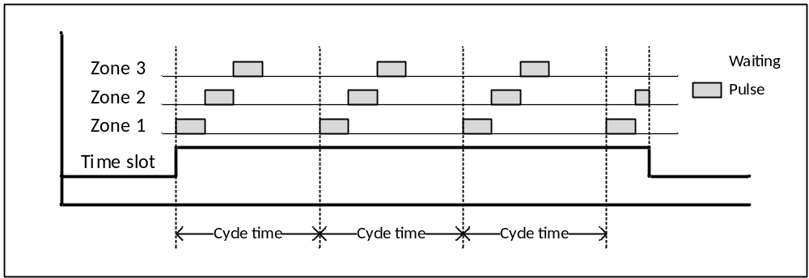
Figure 2: Timing diagram in case requested opening time less than cycle time.
In case this occurs because the total requested opening time is too long (for example when the available water isn’t sufficient) the time between the pulse will automatically be extended for all zones.
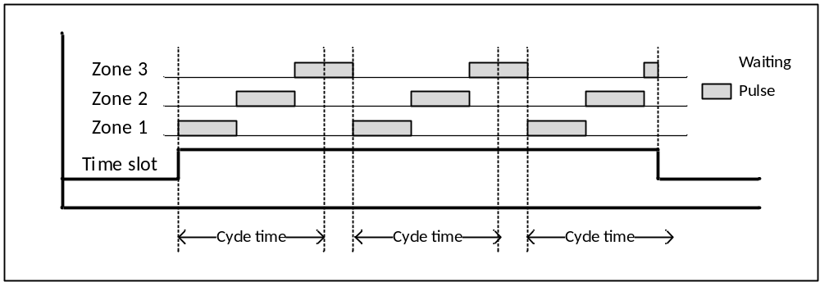
Figure 3: Timing diagram in case requested opening time longer than cycle time.

Options
The new functionality requires following changes in the installation menu for ‘Spraying’:
Add divider: ‘Valves simultaneous’:
In the installation menu for spraying the divider ‘Valves simultaneous’ with undermentioned settings should be added just before ‘Areas’.
Please note: It is obviously that limiting the number of valves simultaneous has no effect when there is only one area with only zone, we still choose to show this option regardless the number of areas or zones.
Add option: ‘Limit number of valves simultaneous’:
In case ‘Spraying’ is activated an extra option ‘Limit number of valves simultaneous’ appears. Here the installer can set with a checkbox whether the number of valves of that may switch on simultaneous should be limited. This option is off by default.
Add option: ‘Maximum valves simultaneous’:
In case the option ‘Limit number of valves simultaneous’ is activate the option ‘Maximum valves simultaneous’ appears. Here the installer can set how many valve outputs may be activated simultaneous. This value can be set from 1 to 5 and has a default value of 1.

Settings
The new functionality requires no extra settings.

Main group
The overview screen for spraying shows the status of the zones with the colour of the spraying symbol: grey is inactive, white is active and bleu is valve on. Adding a colour to indicate a cycle is pending would probably overcomplicate it, so we leave the overview screen the same.

Diagnosis
On products like the Orion-GC and Thomas-BF we have similar functionality with water valves or feeding cycles waiting in a queue. On these product we have diagnosis screens that show the queue, so the user can see what’s waiting in the queue or even delete items from the queue. In this case that seems a bit exaggerated. The pulses for the valves that are waiting in the queue are relative short, so will be the waiting times. In addition, the valves will be removed from the queue when they no longer match the conditions for spraying.

Alarms
The new functionality requires no extra alarms.

Logging
To enable future logging the TC2 calculates the duty cycle of the valves when spraying is active. By adding the limitation on the number of valves that may be active simultaneous some waiting time can be added to the cycle and the actual duty cycle can be affected. We assume that the addition of wating time will be incidentally (like in figure 2) and not structurally (like in figure 3) therefore we choose to neglect these effects and leaf the calculation of the unchanged.

